Acupuncture Naturally @ Beverly Chiropractic & Wellness
Dr. Brenda Kohut R.Ac

∗PLEASE BE AWARE THAT ALL INFORMATION GATHERED HERE IS NECESSARY FOR A COMPLETE DIAGNOSIS AND WILL BE KEPT STRICKTLY CONFIDENTIAL∗

Patient Information
Name: ______________________________ Today’s Date: _________________________ Age: ________
Date of Birth: ____________________ Occupation: __________________________ M: ______ F: ______
Address: _____________________________________________ Email: ___________________________
Home Phone#: ___________________ Work Phone#: ____________________ Cell#: ________________
Emergency Contact Name: ______________________________ Phone #: __________________________
Doctor: ______________________ Height: ____________ Weight: ____________ Blood Type: ________

How did you hear about the clinic? colleague family therapist doctor internet signage friend other: _____________________
Primary Concern: _______________________________________________________________________

______________________________________________________________________________________

______________________________________________________________________________________

Secondary Concerns: ____________________________________________________________________

______________________________________________________________________________________

I. Health History

1. Operations/Hospitalizations
Date | Diagnosis/Reason | Procedure

2. Current Medications/Supplements
Name | Dose and Frequency | Reason

3. Allergies/Sensitivities
Substance/Food or drug | Reaction

Dr. Brenda Kohut, Registered Acupuncturist
Page 2

4. Family Medical History: Check any conditions family members have or have had.
Condition | Mother | Father | Sister(s) | Brother(s) | Child(ren)
Arthritis
Asthma
Cancer
Depression
Diabetes
Heart Disease
High Cholesterol
Hypertension
Kidney Disease
Stroke
Other
Other

5. Your Medical History: Circle any conditions you currently have or have had.
HIV/AIDS | Eczema | Hepatitis | Pneumonia
Anemia | Emphysema | High Cholesterol | Post Traumatic Stress Disorder
Arthritis | Epilepsy | Hypertension | Seizures
Asthma | Fatigue | Irritable Bowel | Stomach Issues
Bronchitis | Fibromyalgia | Kidney Disease | Thyroid Issues
Cancer | Gallbladder issue | Liver Disease | Ulcer
Depression | Gout | Lupus | Other
Diabetes | Heart Disease | MS

II. Lifestyle
1. Habits: Indicate frequency and type
Coffee/tea: ________#/day Exercise: ____________________min/hour per week____________
Alcohol: ______ # per week Relationship stress: _______________________________________
Pop: ________# per day/week Work-related stress: _______________________________________
Tobacco: ________# per day Other Stress: _____________________________________________
Marijuana: _______ per day/week
Water: ________per day cold(ice) room temperature hot (tea) sip gulp

2. Diet/Appetite
Appetite description: Please check one
Excessive Good Fair Poor Absent
List specific cravings and how often you indulge: ______________________________________________
______________________________________________________________________________________
List any digestive disturbances: ____________________________________________________________
______________________________________________________________________________________
Describe your typical diet (i.e. fast food, carbs, vegetables, fruit, proteins, liquids):
Breakfast______________________________________________________________________________
Lunch_________________________________________________________________________________
Dinner________________________________________________________________________________
Dr. Brenda Kohut, Registered Acupuncturist

Page 3

III. Current Health
Please circle (Y) yes or (N) no for the following ailments.
Emotional problems | Y | N | Night sweats | Y | N
Mood swings | Y | N | Easy perspiration | Y | N
Depression | Y | N | Headaches | Y | N
Anxiety/nervousness | Y | N | Vision problems | Y | N
Stress/Tension | Y | N | Eye pain, strain, blurring, dry, tearing | Y | N
Fatigue/insomnia | Y | N | Hearing loss | Y | N
Thirst | Y | N | Earache/ringing | Y | N
Memory problems | Y | N | Sinus problems | Y | N
Dizziness | Y | N | Painful urination | Y | N
Chills | Y | N | Urinary problems/incontinence | Y | N
Fever/heat | Y | N | High/low blood pressure | Y | N
Skin problems | Y | N | Angina/chest pain | Y | N
Lumps | Y | N | Palpitations | Y | N
Sore throat | Y | N | Easy bleeding/bruising | Y | N
Swollen glands | Y | N | Abdominal pain/cramps | Y | N
Cough | Y | N | Fainting | Y | N
Shortness of breath | Y | N | Nausea | Y | N
Edema | Y | N | Constipation | Y | N
Blood in stool | Y | N | Loose stools/diarrhea | Y | N
Hemorrhoids | Y | N | Muscle spasm | Y | N
Back pain | Y | N | Low back pain | Y | N
Joint pain/ache | Y | N | Neck pain | Y | N
Pain anywhere else in the body | Y | N
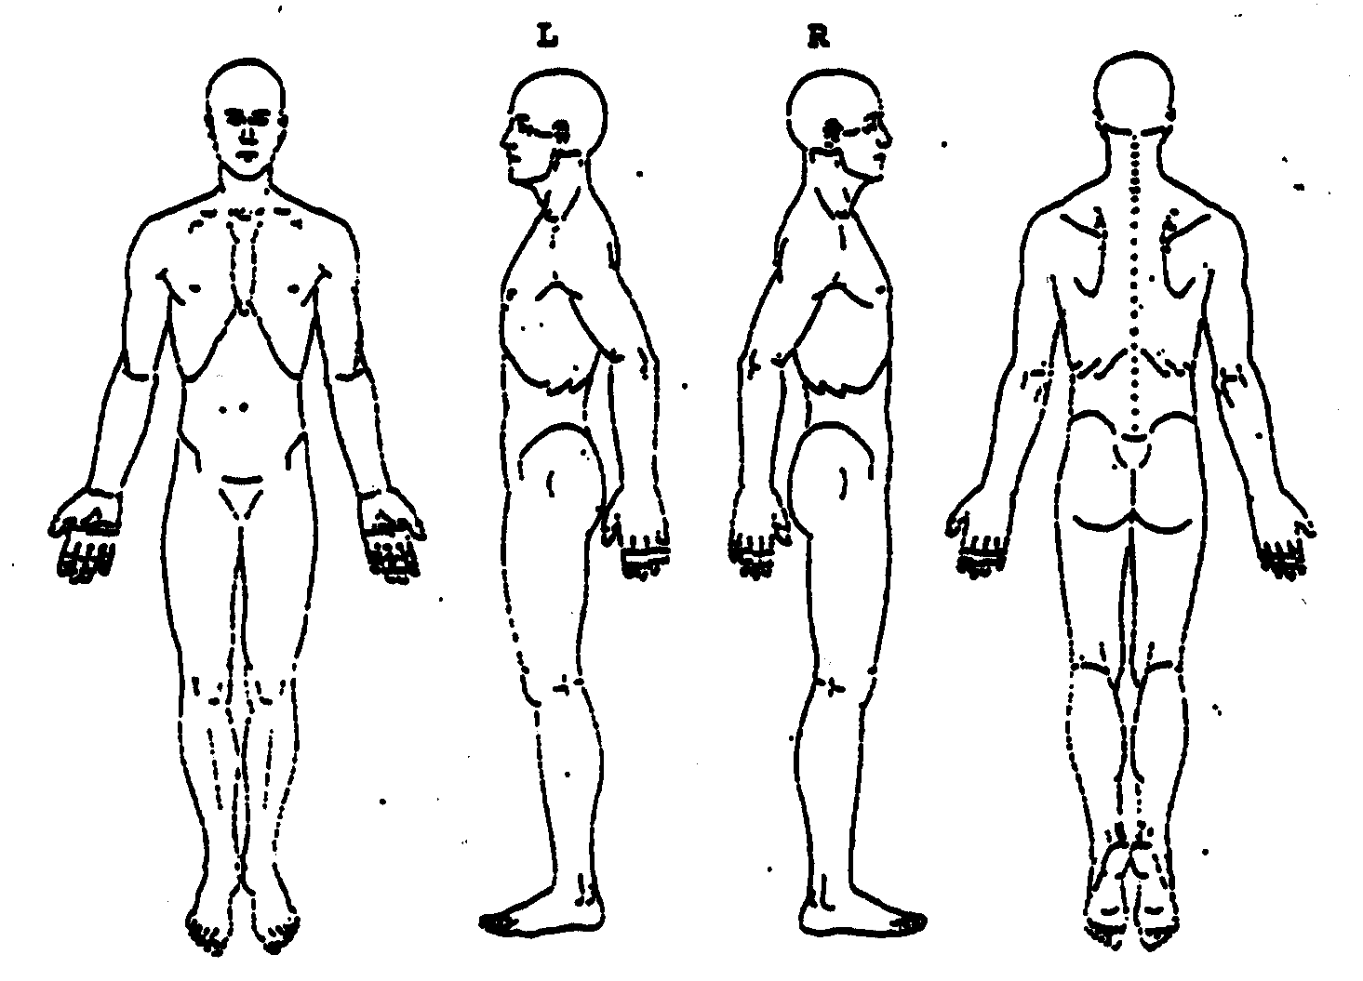
Please circle areas of concern
Dr. Brenda Kohut, Registered Acupuncturist
Page 4

IV. Gynecological History

Menstrual History
1. Period
Age of first period: ______years old
Do you still have a period? yes no Date of last period: __________________
If yes, are your periods regular? yes no
How many days between periods? _________days Length of period: ____________days

- PMS SYMPTOMS
none before menstruation during menstruation mid-cycle
emotional
breast swelling
breast tenderness
back pain
acne
headache/migraine
abdominal bloating
pelvic pain/cramps

3. BLEEDING: Please indicate the appropriate descriptions
Color Texture Quantity Clots
pale red thin scanty yes no
bright red thick large amount If yes, how big? _______________
dark red sticky flooding How many days? ______________
brown with mucous

Do you bleed between periods? yes no

4. PAIN: Please indicate the appropriate descriptions.
Nature of pain: Time of pain: Better with: Worse with:
achy & dull before period pressure pressure
dull & heavy during period warmth warmth
bloating after period cold cold
sharp, stabbing other: ___________ other: ___________
burning
boring, fixed pain
other: ____________________

5. CONTRACEPTIVE USE
Have you ever used contraception? yes no Are you currently using contraception? yes no

List all contraceptives you are using or have used in the past.
Type or name of contraception | From when to when? | If not currently using, reason for discontinuation

Dr. Brenda Kohut, Registered Acupuncturist

Page 5

6. PREGNANCY HISTORY
Are you currently pregnant? yes no If yes, how many months? _______________
Are you trying to get pregnant? yes no If yes, since when? ____________________

Please provide a history of your pregnancies
Date | T=term  P=premature | Miscarriage | Elective abortion | Ectopic | Stillborn | N=natural  C=caesarean

7. MENOPAUSE
Are you currently going through menopause? yes no If yes, when did it begin? ______________

Describe the symptoms you are experiencing or have experienced: ________________________________ ____________________________________________________________________________________________________________________________________________________________________________

Have you passed through menopause? yes no
If yes, how old were you when it began? __________ When was your last period? ___________________
Describe the symptoms you experienced: ____________________________________________________
______________________________________________________________________________________

Date of last PAP Smear: _________________ Date of last Mammogram: _________________________

V. Sexual symptoms
Men: please indicate any symptoms you have or have had in the past.
Testicular pain Lack of libido High libido Unable to get an erection Unable to sustain an erection Premature ejaculation
Ejaculation during sleep Tired and dizzy after ejaculation Prostate problems

Women: please indicate any symptoms you have or have had in the past.
Lack of libido High libido Unable to reach orgasm
Headache after orgasm Pain with intercourse Bleeding with intercourse

List any sexually transmitted diseases you currently have or have had in the past:
Sexually Transmitted Disease | Date of last flare up | Treatment | Current Status

Dr. Brenda Kohut, Registered Acupuncturist

Dr. Brenda Kohut Doctor of Acupuncture, R.Ac., Dipl.S.T.
Acupuncture Naturally @ Beverly Chiropractic & Wellness

INFORMED CONSENT FOR ACUPUNCTURE CARE

I hereby request and consent to the performance of acupuncture and other procedures related to acupuncture if necessary including needling, moxabustion, tui na, cupping, gua sha, laser, electro acupuncture, herbology, and other techniques within the scope of practice of acupuncturists names above and/or anyone working in this clinic authorized by the registered acupuncturist listed below.

I have had the opportunity to discuss with the registered acupuncturists and/or with other office or clinic personnel the nature and purpose of acupuncture care and other procedures. I understand that results are not guaranteed.

I further understand and am informed that, as in all health care, in the practice of acupuncture even though all the needles are presterilzed and disposable there are some slight risks to treatment including but not limited to temporary soreness, bruising, blistering, nausea, fainting, bleeding, infection, and shock. I do not expect the acupuncturist to be able to anticipate and explain all risks and complications and I wish to rely on the acupuncturists to exercise judgment during the course of the procedures which the acupuncturists feels at the time, based upon the facts then known, are in my best interest.

I have been advised that only pre-sterilized needles will be used. All acupuncture needles are properly disposed of after each and every treatment.

I have read the above consent. I have also had an opportunity to ask questions about its content, and by signing below I agree to the above named procedure(s). I intend this consent form to cover the entire course of treatment for my present condition and for any future condition(s) for which I seek treatment.

___________________________ _____________________________
Print Patient’s Name Signature of Patient

___________________________
Date

___________________________
Registered Acupuncturist’s Signature

